**Chapter 1**

**Introduction**

**1.1 Overview**

**1.1.1 Feed Happiness:**

This project is created to provide “efficient, compatible, easier” service for user. This idea would help the user in easier and better way. As per the previous system the user or donor had to each and every process manually, but this system will help user to make their donations bit faster. The user can donate each and everything to the specific charity organization as per their convenience. This web based application will provide various types of donations to needy people .Both Donor and NGO have to register in the website for efficient communication between them. Donor will have to fill all the required details for his/her identity and NGO too have to fill their details with location. The information are stored confidentially in computerized format. After donation of donor, the dashboard is provided to see the NGOs to which they have donated. As same, the dashboard containing donor information will be displayed at NGO side.

**1.2 Need**

Since gaining Independence in 1947, instead of being able to eradicate the poverty, India has added poors and houses poorest people in the world. **Food, Clothing and Shelter are still a big issue in India**. So, helping this type of people to get in good condition, providing them basic belongings, making good environment for motivating them this kind of organizations are required who will support them in any situations as a part of the society.

**1.3 Problem Definition**

In the existing system the donations are carried out manually as per their specific NGO website. The person has to visit the website of specific NGO and have to submit the details of self and donation and then they have to wait for approval. A specified NGO website for their Specified donation. The process of donating is hard to understand. Contribution of people is very low. It is much of time consuming process and more importantly it is error prone. User can facing lot problems.

**1.4 Social Service**

Organizational website will work for needy people without expecting any refunds so it is best social service. All the donors are donating cloths and other basic needs to nearby Organization without any condition for helping NGO. For the development of people and country this type of organizational website is required.

* 1. **Objectives**

The main objective of Project “Feed Happiness” is an overview as an helping hand towards the welfare of the society. The goal is to ensure that to provide food and basic needs to needy and unfortunate people which they deserve.

* Easy donating system for donors.
* Easy registration for both donor and NGOs.
* Central management system.
* Easy communication.
* Consumes less time.
* Advance security for data storing.
* Donation is done equally among all.
* Dashboard displayer.

**Chapter 2**

**Literature Survey**

This section provides a detailed literature review specifically about the existing

applications for the donation, which are trying to increase and activate the donation process and make it easier. There are numbers of existing systems and charities organization that are increasingly trying to activate the donation process, to make it more suitable and use the technology to reduce the effort of the donator. This section will explore some charities donation process and recent works in this field one by one.

Eta‟am charity organization is a charity organization that mainly focuses on helping needy people by collecting extra healthy food from different parties and delivers it to

needy people after packing. Their process of donation is that the donator should contact the charity and tell them about the type of the food and best suitable time and date to collect the food.

* Only accepting food donations from big ceremony minimum invited are 70 guests.
* The donator cannot create account, each time they have to fill up the form repeatedly and send it to the charity.
* There is no interaction between the donors and the charity.
* The needy people cannot register them self in easy way in order to receive donations.
* The registered needy people by the charity cannot update their location automatically in case if their location is changed. They do not use the technology in efficient way.
* Donators have to visit the charity organization in order to donate physical donation like „Clothes‟.
* The charity ignores the donation boxes for long time.
* The cost of checking the donation boxes is high and makes a lot of effort to the charity employee.
* There is no mechanism to check the status of donation boxes.
* The needy people cannot set a priority of their need.

**2.1 Existing System**

Existing donation systems couldn’t provide multi-donation facility to willing donor to donate verified NGO. The process of donating is hard to understand. Contribution of people is very low.

* Difficult donating system for donors.

Existing donation systems couldn’t provide multi-donation facility to willing donor to donate verified NGO. The process of donating is hard to understand. Contribution of people is very low.

* Difficult donating system for donors.
* Consumes more time.
* No Dashboard displayer.
* People interest is also very low.
* Number of engaged people is low.

**2.2 Feasibility Study**

A feasibility study is an analysis of how successfully a project can be completed.

Feed Happiness is developed to help needy and unfortunate people. It can be used by all NGO organizations and the persons who want to donate something to organization. Therefore, Feed Happiness is looking for help to all needy people in any manner.

**2.2 Technical feasibility**

Feed Happiness has provided open source donating system so that anyone can make donation easily. And also NGO can register for benefits of the website. Anyone can take part and be a part of social activity to achieve a goal. Anyone can take part anytime anywhere.

**2.2 Market feasibility**

Feed Happiness needs to be published. There will be advertisement of it on FM/Radio. Also advertisement in newspaper and will be promoted on social media. Information will be provided to every NGO, and everyone. Feed Happiness can do every possible things to reach maximum people and help them.

**Chapter 3**

**Experimental Setup**

**3.1 Hardware Configurations**

* Operating System : Windows 10
* Processor : Intel i5 processor
* Memory : 4GB RAM
* IDE : Eclipse

**3.2 Software Requirements**

* Language : HTML
* Web server : Apache Tomcat 7.0
* Front End : JSP,HTML,CSS
* Back End : MySql

**Chapter 4**

**System Design**

**4.1 Use Case Diagram**

Donor

Receiver

TPV

Admin

Release 3

Release 2

Release 1

Release 1

Release 2

Fig:4.1 Use Case Diagram

**4.2 Data Flow Diagram**

USER

NGO

Database

Make Donation

Fetch data

Fetch data

Fig: 4.2: Data Flow Diagram 0 (DFD 0)

NGO

Donor

NGO

Donor

NGO

Donor

NGO

Donor

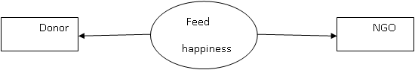

Fig 4.3 : Data Flow Diagram 1 (DFD 1)

User

Login

Registration

Password

Username

Fill Details

Registered

Logged in

Database

Fig 4.4: User/Donor

**Advantages**

* Easy donating system for donor.
* Helps People Who Can't Afford Clothes.
* Ngo registration for the farmers.
* Very simple user interface of web.
* Donation is done quickly.

**Chapter 5**

**Sample Calculation**

### 5.1 Testing

### Software testing is a process of executing a program or application with the intent of finding the software bugs software bugs Software testing is information about the quality of the software product or service under test. Software testing can also provide an objective, independent the software to allow the business to appreciate and understand the risk of software implementation. Test techniques include the process of executing a program or application with the intent of finding software bugs (error other defect), and verify that the software product is fit for use.

### White box testing

## ln this the structure of a program is taken into consideration. The objective of this testing to ensure each and every line of the code is tested. It is also called logic driven structural testing. The tester derives test data from an examination of program logic and structure.  While box testing should tell you exactly what material it covers. Since its dynamic, it  must be about testing a running program and since its white box, it must be about looking inside the box, examining the code and watching it as it runs. It is like testing the software.

## Dynamic white-box testing, is using information you gain from seeing what the code does how it works to determine what to test, what not to test, and how to approach the testing. Other name commonly used for dynamic white-box testing is structural testing because u can see and use the underlying structure of the code to design and run your tests. Dynamic white-box testing is not limited just to seeing what the code does. It also involves directly testing and controlling the software.

## White box testing(also known as clear box testing ,glass box testing ,transparent box testing ,and structural testing )is an application, as opposed to its functionality(i.e. black-box testing ). In white box testing an internal and perspective of the system, as well as programming skills, are used to design test case. The tester chooses input to exercise path through the code and determine the excepted outputs. This is analogous to testing nodes in a circuit, e.g. in-circuit testing (ITC). White-box testing process. Although traditional tester tended To think of white-box testing as begin done at the unit level, it is used for integration and system more frequently today. It can test the path within a unit, paths between unit during integration, and between subsystems during a system-level test. Though this method of test design can uncover many error or problem, it has the potential to miss unimplemented parts of the specification or missing requirements.

**Black Box Testing**

It is also known as behavioral testing, is a software testing method in which the internal structure/design/implementation of the item being tested is not known to the tester. This test can be functional or non-functional, though usually functional.

The method is named so because the software program, in the eyes of the tester, is like a black box; inside which one cannot see. This method attempts to find errors in the following categories:

* Incorrect or missing functions.
* Interface errors.
* Errors in data structures or external database access.
* Behavior or performance errors and Initialization and termination errors.

In this the structure of the program is not considered. The software is considered as a black box to which defined inputs are given. From this the defined outputs are obtained. In  the tester only knows what the software is supposed to do but he cannot look in the box to see how it operates .This testing has to be done in lab (Alpha Testing) and at users site (Beta Testing). During planning stage the time for Alpha & Beta are fixed. The black box testing finds the errors such as interface errors, incorrect and missing functions, initialization and termination error, performance error, errors in structure and external database access etc.

It is also called data-driven testing. For testing our project, we used Black Box Technique. We prepared test cases among our friends. Using these test cases we tested this project. Black box testing is not a type of testing strategy, which does not need any knowledge of internal design or code etc. As the name “black box” suggests, no knowledge of internal logic or code structure is required. 

This testing technique treats the system as black box or closed box. The types of testing under this strategy are totally based/focused on the testing for requirements and functionality of the work product/software application. Black box testing is sometimes also called as “Opaque Testing”, “Behavioral Testing” and “Closed Box Testing”. The base of the Black box testing strategy lies in the selection of appropriate data as Per functionality and testing it against the functional specification in order to check for abnormal and abnormal behavioral of the system.

Now a day, it is becoming common to route the Testing work to a third party as the developed of the system knows too much of the Internal logic and coding of the system, which makes it unit to the test the application by the developer. In order to implement by black box testing strategy, the tester is needed to be through With the requirement specification of the system 'and as a user, should know, how the system behave in response to the particular action. Various testing types that for under the black box testing strategy are : functional “sling, stress testing, recovery testing, volume testing, user acceptance testing, system testing . Wing, sanity or smoke testing, load testing, usability testing, exploratory testing. Ad-hoc testing alpha and beta testing.

**Unit Testing**

The primary goal of unit testing is to take the smallest piece of testable software in the application, isolation it form the reminder of the code, and determine Whether it behaves exactly as you expect. Each unit is tested separately before integrating them into modules to test the interfaces between modules. 

Unit testing has proven its value in that a large percentage of defects are identified during its use. The most common approach to unit testing requires drivers and stubs to be written. The driver simulates a calling unit and the sub simulates a called unit.

**Why is unit testing useful?**

Writing unit tests helps produce higher Quality code on many levels:

* The availability of tests helps detect the introduction of bugs whenever the programmer adds new features or re-factors the code. This is called regression testing.
* Tests also serve as a source of documentation about what code is really expected to do.
* The act of writing the tests challenges the programmer to consider possible edge cases and their consequences.

**Integration Testing**

Integration testing is a logical extension of unit testing. In its simplest form, two units that have already been tested are combined into a component and the interface between them is tested. A component, in this sense, refers to an integrated aggregate of more than one unit. In a realistic scenario, many units are combined into components, which are in turn aggregated into even larger parts of the program. 

The idea is to test combinations of pieces and eventually expand the process to test our modules with those of other groups. Eventually all the modules making up a process are tested together. Beyond that, if the program is composed of more than one process, they should be tested in pairs rather than all at once.   
  
Integration testing identifies problems that occur when units are combined. By using test plan that requires you to test each unit and ensure the viability of each before combining its, you know-that any errors discovered when combining units are likely related to the interface between units.

**Test Deliverables**

The following items will be generated by the system test group of this project

* System test plan.
* System test design specification.
* System test case specification.
* System test procedure specification.
* System test logs.
* Test scripts.
* Test data.
* Input/ Output files.
* Security test input and results.
* Query input screen and results.

**Testing Strategy**

The test strategy consists of a series of different tests that will fully exercise the Email Client (EMCL-08) The primary purpose of these tests is to uncover the systems limitations and measure its full capabilities. A list of various planned tests and a brief explanation follows here.

1. **System Testing**: The system will focus on the behavior of the Email Client (EMCL-OS). After the Integration Level testing is over, the System Testing is carried out. The System Testing is carried out against the Functional Specifications. In this testing, all the modules, sub-modules, connections between modules are again tested thoroughly. System testing has a destructive approach and it is the final testing before carrying out the Acceptance Testing or the User Acceptance Testing.
2. **Performance testing**: Performance test will be conducted to ensure that the Email Client (EMCL-O8) response time meets the user expectation and doesn’t exceed the specified performance criteria. During these tests, response time will be measured under heavy stress and /or volume.
3. **Security testing**: Security tests will determine how secure Email Client (EMCL-08) . The system is thoroughly tested from the security point of view. Access controls are checked at the user level, menu level, file level and field level. The Security Testing assumes great importance when the system is web-based.
4. **Recovery testing**: Recovery tests will force the system to fail in a various ways and verify the recovery is properly performed. In the Recovery testing, the backup procedures are checked. The performance of the system during recovery procedures is tested.
5. **Documentation test:** Test will be conducted to check the accuracy of the user documentation. This test will ensure that no features are missing and the contents can be easily understood.

**Test Cases**

Test cases have some parameters such as:

* Test case ID
* Test Description
* Expected Result
* Actual Result
* Status

|  |  |  |  |  |
| --- | --- | --- | --- | --- |
| Test case id | Test Description | Expected Result | Actual Result | Status |
| TC-1 | Donation user  Login page | The accurate login page will be open | Login page open | pass |
| TC-2 | Enter valid user name and valid password | User login successful | Login successful | Pass |
| TC-3 | Donor login page | The accurate login page will be open | Donor login page open | Pass |
| TC-4 | Enter valid donor user name and valid password | Donor will be logged in successful | Logged in successful | Pass |
| TC-5 | NGO login page | The accurate login page will be open | NGO login page open | Pass |
| TC-6 | Donation user registration | Registration field should be enable | Registration field will be enable | Pass |
| TC-7 | NGO registration | Registration field should be enable | Registration field will be enable | Pass |

**Chapter 6**

**Result and Snapshots**

**Home Page :**

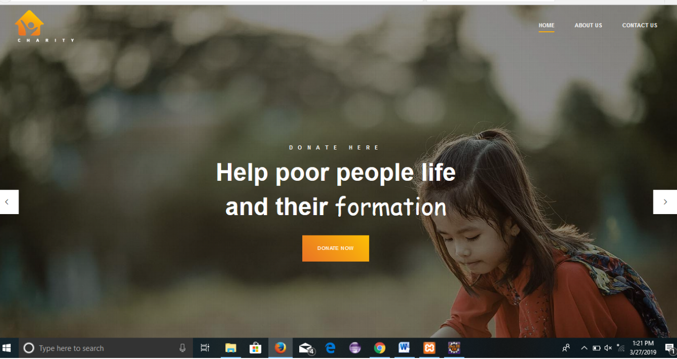

**Login Page :**

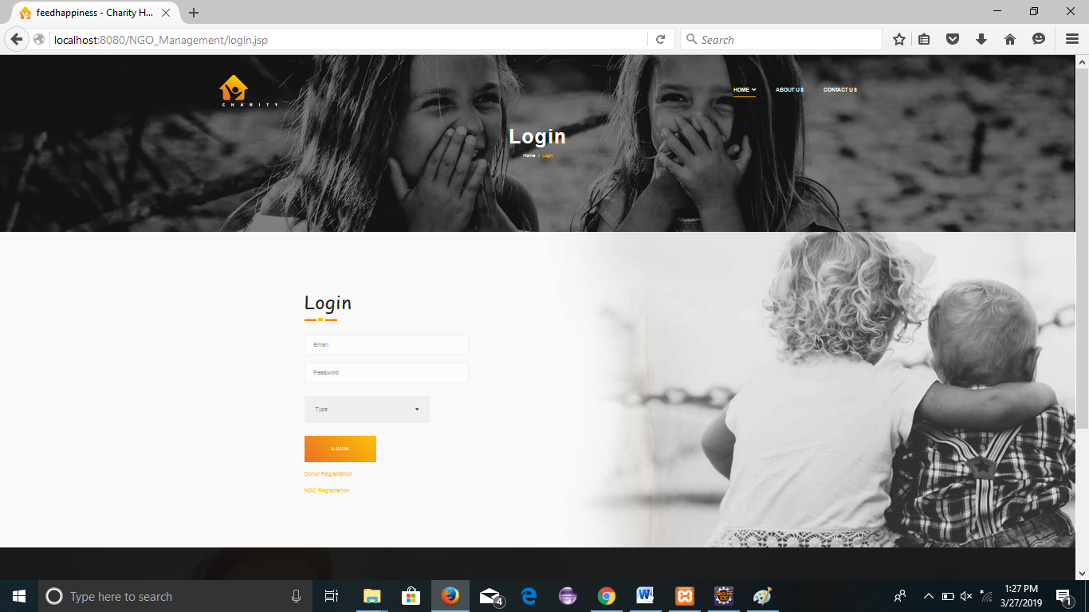

**Donor Registration Page :**

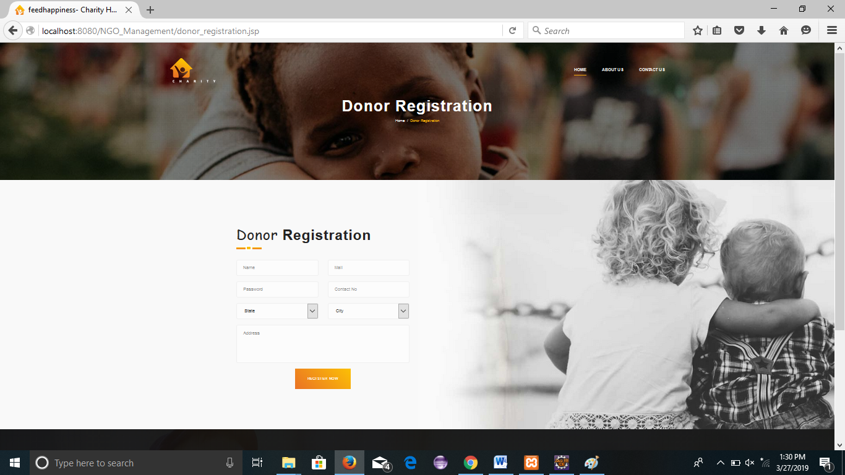

**NGO Registration Page :**

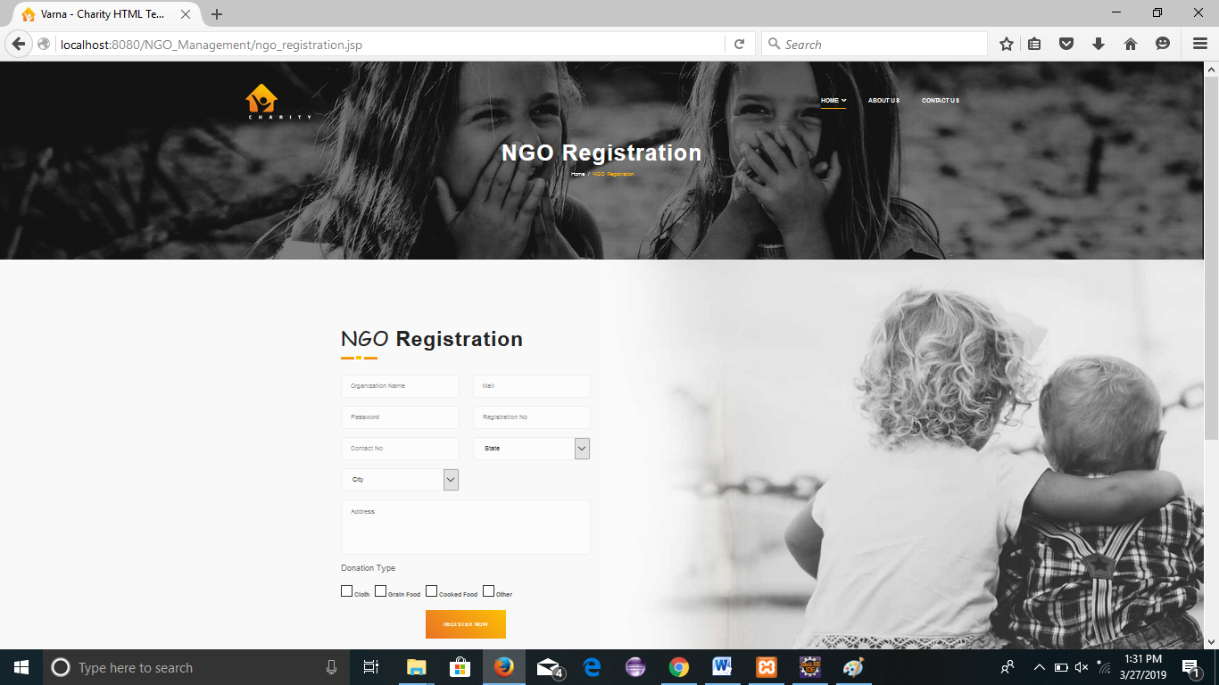

**Donation Page :**

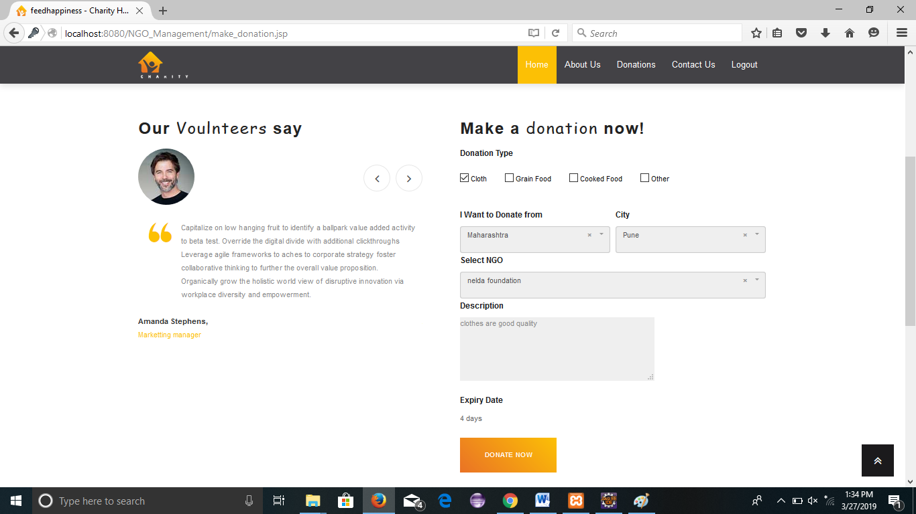

**Dashboard Page:**

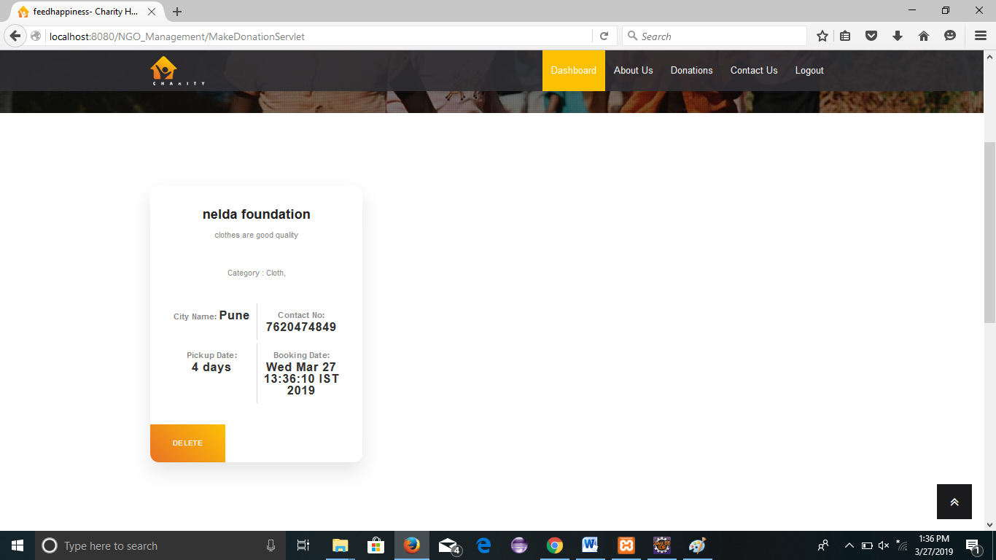

**Contact us Page :**

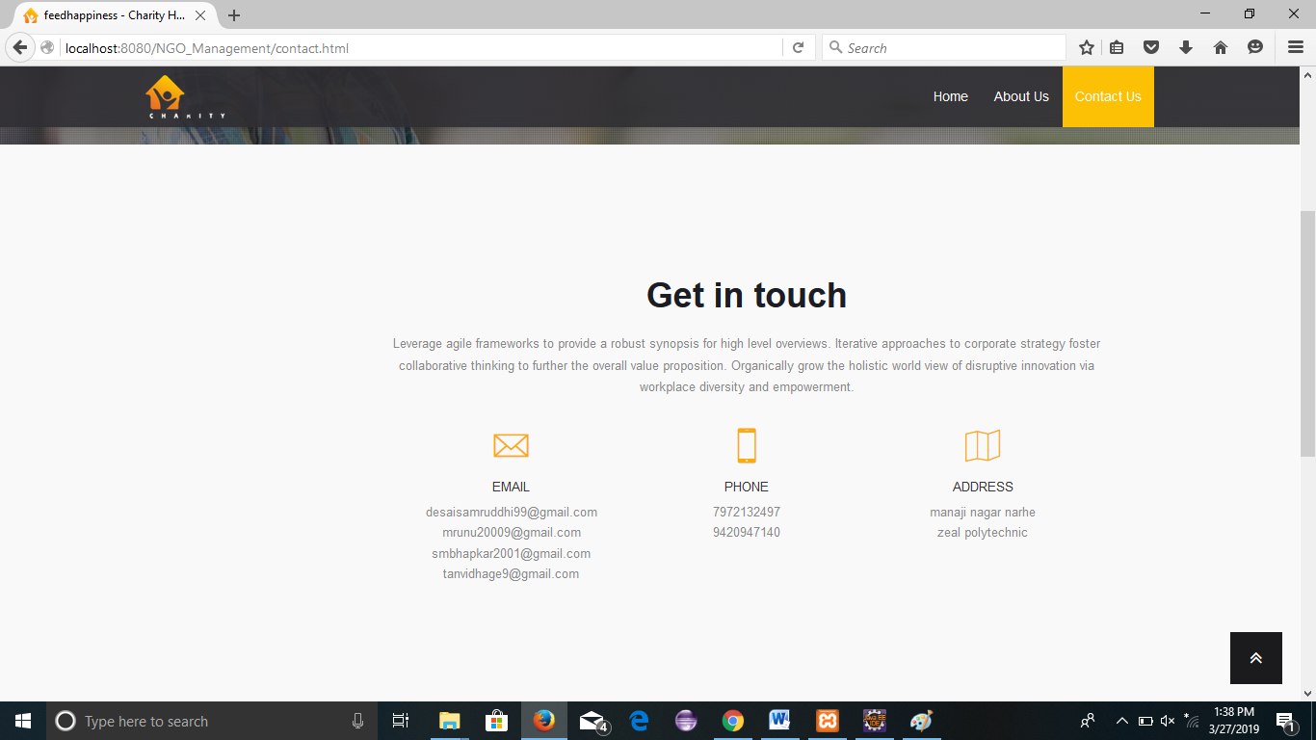

**About us Page :**

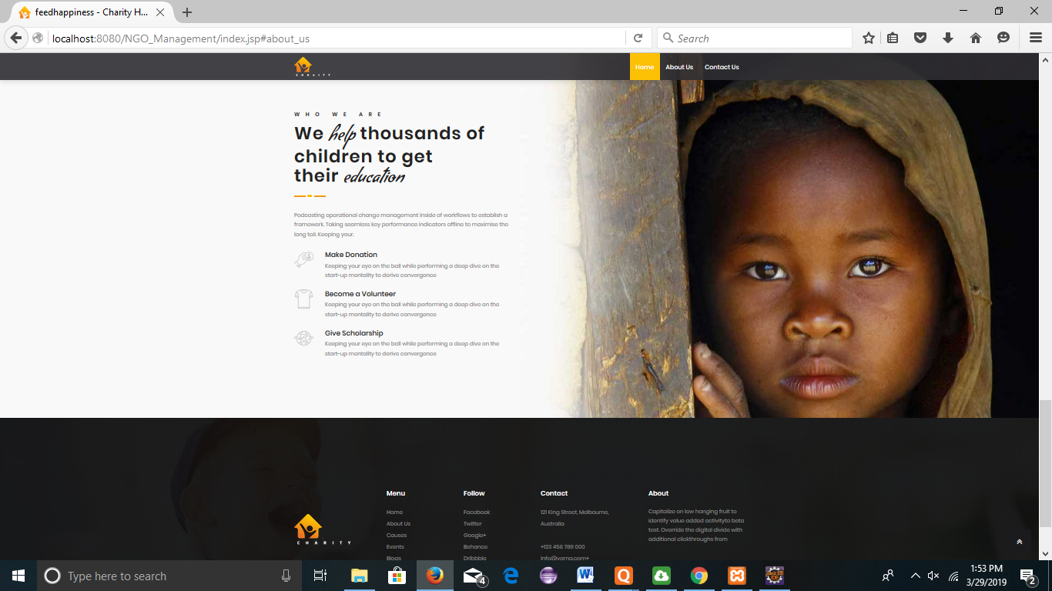

**Chapter 7**

**Applications**

**Applications:**

* Useful for the social trust
* Useful for willing donors
* Providing platform to people who want to donate
* Used by an organization

**Chapter 8**

**Conclusion**

**Conclusion**

The main goal of the Smart Charity System is to help the society in a modernized way using new era technologies to make donations and charity operations more efficient. The system introduced smart solution for the charity organizations and donation boxes.

**Chapter 9**

**Future Scope**

**Future scope**

The main aim of Feed Happiness is to get maximum numbers of beneficiary people .Feed Happiness should be available to all needy people. Enhanced web appearances, advanced security. In future, notifications will be provided to specific Organization and Donors. Also, providing funds to the NGOs through our website.

**Chapter 10**

**References**

**Reference:**

[www.google.com](http://www.google.com)

[www.w3school.com](http://www.w3school.com)

www.jsptutorials.com

[www.wikipedia.com](http://www.wikipedia.com)

[www.stackoverhow.com](http://www.stackoverhow.com)

[www.askmeanything.com](http://www.askmeanything.com/)

[www.codeproject.com](http://www.codeproject.com/)

[www.stackxchange.com](http://www.stackxchange.com)[www.dotnetfunda.com](http://www.dotnetfunda.com/)

International Journal Of Recent Treads In Engineering And Research “*Food Wastage*

*Reduction Through Donation*”.